Experiment 7 M. Devarajulu
Aim 192212058
To solve and implement BFS by using python program
Algorithm
1. Start from the source node.
2.Mark the source node as visited and enqueue it.
3.While the queue is not empty:
- Dequeue a node and visit it.
- Enqueue all its unvisited adjacent nodes.
4.Repeat until all reachable nodes are visited.
Program
# Function to perform BFS
def bfs(graph, start):
visited = set()
queue = deque()

visited.add(start)
queue.append(start)

print "BFS Traversal:"

while queue:
node = queue.popleft()
print node,

for neighbor in graph[node]:
if neighbor not in visited:
visited.add(neighbor)
queue.append(neighbor)

# Graph represented as an adjacency list
graph = {
'A': ['B', 'C'],
'B': ['D', 'E'],
'C': ['F'],
'D': [],
'E': ['F'],
'F': []
}

start_node = 'A'

bfs(graph, start_node)

Output

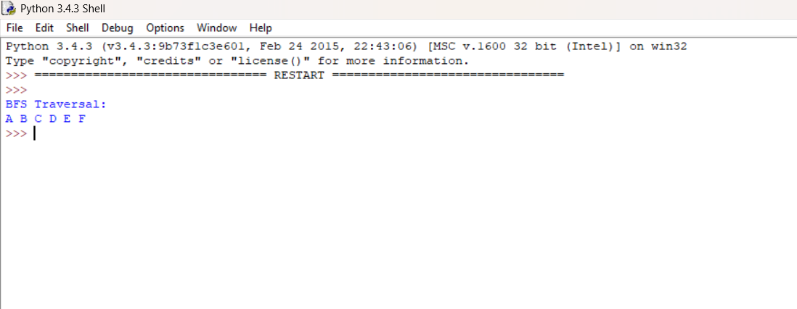

Result
The Breadth-First Search (BFS) algorithm starts from node A and visits all neighboring nodes level by level using a queue. The traversal order obtained is:
A B C D E F

